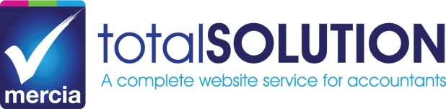

Pension Auto Enrolment – website text to be used by Mercia totalSOLUTION customers only. This text is provided as a guide and you may edit as you wish. Please email our team at [totaltechnical@mercia-group.co.uk](mailto:totaltechnical@mercia-group.co.uk) in order to have this content included in your website.

**Pension Auto Enrolment**

Whether you have one employee or 100 employees, auto enrolment places significant responsibilities on an employer. Employers need to enrol many of their employees into a work based pension scheme and pay some pension contributions.

We can help you:

* Prepare for the start of auto enrolment in your business including an initial analysis of your workforce, preparation of a cost budget and assistance with choosing an appropriate qualifying pension scheme
* Prepare communication letters to your employees
* Calculate employee and employer contributions and prepare payment schedules for the pension scheme provider
* Assess your workers each pay day to determine if they need to be auto enrolled
* Register with The Pensions Regulator and help you keep the required records